SCHOOL WEBSITE: https://secure1.nbed.nb.ca/sites/ASD-W/Chipman/Pages/default.aspx

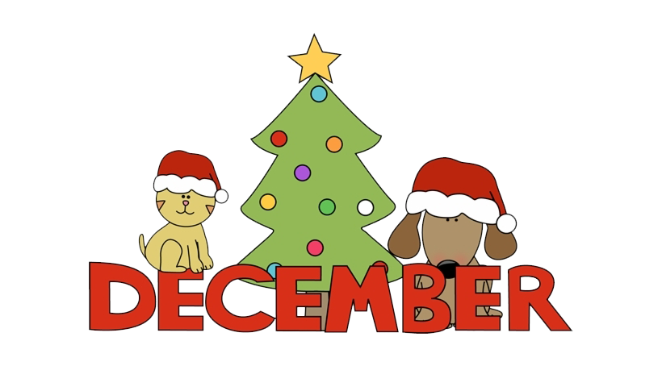 | 2021
Sunday | Monday | Tuesday |  | Wednesday |  | Thursday |  | Friday | Saturday
 |  |  |  |  | 1 |  | 2 | 3 | 4
No School for Students
½ Day PL
½ Day Parent/Teacher 1-3pm
5 | 6 | 7 |  | 8 |  | 9 |  | 10 | 11
12 | 13 | 14 |  | 15 |  | 16 |  | 17 | 18
19 | 20 | 21 |  | 22 |  | 23 |  | 24 | 25
 | Red/Green Day | Christmas Hat/Headband Day |  | Christmas Sweater/  T-shirt day |  | Christmas PJ Day  LAST DAY FOR STUDENTS |  | CHRISTMAS EVE | CHRISTMAS
26 | 27 | 28 |  | 29 |  | 30  Merry Christmas & Happy Holidays from CES |  | 31
JANUARY 10TH – FIRST DAY BACK FOR STUDENTS
School Closures:
Please listen to the local radio stations for announcements regarding school closures. Chipman Elementary is in Anglophone School District West and in Zone 8.
You may call 453-5454 after 6:00am or check out our website.

In the event that school may be cancelled during the day due to inclement weather we will contact students’ home to ensure safe arrival.

Wishing you and yours a Merry Christmas and a Happy and Safe holiday!

